**Dynamics of the Russian Companies’ Stock Prices in the Context of Economic Shocks**

Lyudmila Gadasina [0000-0002-4758-6104], l.gadasina@spbu.ru

Lyudmila Vyunenko [0000-0002-9741-3949], l.vyunenko@spbu.ru

Ivan Labutkin [0009-0009-5067-3848], st087336@student.spbu.ru

St Petersburg University, 7/9 Universitetskaya nab.,

Saint Petersburg 199034, Russian Federation

**JEL code: C650, C380, E650**

**Abstract**

The aim of the study is to develop an approach that allows grouping mid-frequency time series of economic indicators according to the principle of trend changes similarity over time. The approach includes series smoothing to eliminate short-term changes and uses clustering time series with the Dynamic Time Warping metric, designed to measure the distance between time series that are not synchronized in time. The approach has been tested to study the impact of negative macroeconomic factors on the share prices of large Russian companies. Negative macroeconomic factors include the COVID-19 pandemic and the imposition of sanctions in 2022. We introduced a one-month limit on possible desynchronization of rows. Analysis of the negative macroeconomic factors impact on the resulting clusters was carried out by studying the behavior of cluster prototypes obtained using the Partitioning Around Medoids method. The analysis showed that the behavior of stock prices is determined not only by belonging to a particular industry, but is associated with other factors. The hypothesis was partially confirmed that the negative macroeconomic factors under consideration have a greater impact on large companies. In particular, the results confirmed the validity of government measures taken to support large businesses in Russia in the period from 2019 to 2023.

**Keywords:** time series clustering, dynamic time warping, stock prices, negative macroeconomic factors**,** adaptive regression splines

**Introduction**

Over the past few years, a number of events provoking crisis phenomena, such as the COVID-19 pandemic and sanctions, have had a significant impact on the socio-economic life of the Russian Federation and other countries. According to (Ding et al., 2020) the market value of the world's largest stock indexes, such as Standard & Poor (S&P)500, the Automated Quotation System of the National Association of Securities Dealers (NASDAQ)100 and the Nikkei225 index, has fallen by almost 30% since the outbreak of COVID-19. This has considerably affected the financial position of the companies. It is possible to assess the impact of macro- and microeconomic factors on large companies through an assessment of changes in their share prices. Such studies were conducted, for example, in (Kupriyanova, 2018; Malkina and Yakovleva, 2016; Balcilar et al., 2018; Drobot, 2020). The methods used in these studies do not allow us to assess the dynamics of stock prices of a large number of companies in the aggregate. The research in the articles is aimed either at analyzing changes in stock prices of specific companies (Malkina and Yakovleva, 2016), or at analyzing changes in index values (Drobot, 2020), which include companies of only one of the groups. The sanctions had an impact not only on the companies directly affected by them, but also indirectly, by reducing investments, on other companies (Gurvich and Prilepskiy, 2015). Business development is influenced by various factors. The macroeconomic business environment, as well as economic shocks, have a significant impact. At the same time, the same events have different effects on different companies.It is possible to analyze the reaction of a business through an analysis of stock prices, since the economic situation of large companies in the long-term dynamics is characterized by the prices of its shares. The same economic events affect different companies in different ways. There is no universal approach to assess this impact. Hence, the task of developing a tool for identifying groups of companies that respond in a similar way to the external impact of macroeconomic factors on them is urgent. The main purpose of the study is to develop an approach that allows grouping economic indicators time series of medium frequency according to the principle of trend changes similarity over time.

The approach is tested by studying the influence of negative macroeconomic factors on the share prices of large companies in the Russian Federation.

The paper proposes an approach based on a combination of several methods that allows, through an analysis of the sensitivity of stock prices to the influence of macroeconomic factors, to assess alternatives for their impact on companies. As part of the approach, companies are divided into groups by clustering time series of stock prices. The features of the approach methodology and the economic interpretation of the results are discussed.

**Literature review and research hypotheses**

One of the events that had a significant impact on financial markets was the COVID-19 pandemic. The impact of the pandemic on the financial markets of different countries has been studied in many works. In (Shehzad et al., 2020; Mazur et al., 2021; Drobot, 2020), the impact of the pandemic on the volatility of financial markets was discussed. The reaction of the markets in these studies was assessed as the reaction of indices, which are aggregated indicators that include shares of companies with different weights. In the article (Khan et al., 2020), an analysis of the impact of the pandemic on stock indices showed that at the first stage of the pandemic, investors did not react to events, and the indices did not change, but subsequently the index values began to fall. The article (Topcu and Gulal, 2020) conducted a study of the pandemic on stock market indices in developing countries. In the article (Buszko et al., 2021) a study of the impact of the pandemic on the sectoral indices of the Polish stock market was conducted.

In (Naidu and Ranjini, 2021) the effect of coronavirus on the dynamics of ordinary shares listed on the Australian Stock Exchange has been studied. The analysis was conducted at the level of the market, market sector and three categories of company size (top 40%, middle 30% and bottom 30%). The dynamics was estimated based on the analysis of averaged indicators: average abnormal returns (CAR) and cumulative AAR (PAAR). In (Mazur et al., 2021) reactions to the pandemic in various industries were studied (analyzed). Different reactions of companies within the same industry were revealed, that was explained by internal management decisions. The study built separate models for each stock and conducted a comparative analysis.

The study of the pandemic impact on the Russian economic market was conducted, for example, in the article (Zimovets et al., 2020). The authors tested hypotheses about the impact of the pandemic on large and medium-sized businesses, the stock prices of different companies being analyzed separately.

The second event that has had a significant impact on the financial markets of Russia and other countries was the imposition of sanctions. The first package was introduced against Russia by the USA and later by a number of other countries after the Crimean crisis of 2014 and another significant package was introduced after February 22, 2022. The campaign included various sanction types described in (Hufbauer et al., 2009): diplomatic actions (suspension of joint projects, exclusion from international organizations, etc.), measures taken against specific individuals and companies (bans on entry to certain countries, asset freezes, credit restrictions), sectoral sanctions (trade and financial restrictions, bans on technology exports). The sanctions list has been constantly expanding with tighter access to capital markets in the United States and the EU (Ankudinov et al., 2017).

Many articles are devoted to the study of the sanctions impact on both the economy as a whole (Sukharev and Voronchikhina, 2022; Cholodilin and Netšunajev, 2016) and on various markets (Ankudinov et al., 2017; Ghasseminejad and Jahan-Parvar, 2021; Malkina and Yakovleva, 2016; Malkina and Ovcharov, 2022; Costola and Lorusso, 2022).

In (Ghasseminejad and Jahan-Parvar, 2021) the differences in strategies for interacting with political connections and those without such connections were studied. The impact of sanctions on the share prices of companies related to the oil and gas sector were studied in (Malkina and Yakovleva, 2016). A study of large companies' infection from the oil market during the sanctions period was conducted in (Malkina and Ovcharov, 2022).

The main methods used in analyzing the impact of external influences on financial markets are correlation and regression analysis, as well as the study of the moving correlation coefficient. A number of studies have used cluster analysis to identify groups of financial time series that differ in how they are affected by certain external events. We understand cluster analysis as a clustering of a whole time series, i.e. a set of individual time series with respect to their similarity (Aghabozorgi, 2015; Lin et al., 2003). The cluster analysis of stock prices time series in studying the impact of macroeconomic changes on the economy was used in (Buszko et al., 2021). Hierarchical cluster analysis to identify companies with different reactions to COVID-19 was used in the article (Ding et al., 2020). As a result of the study, sensitive and stable clusters (Sensitive Cluster and a Resilient Cluster) were identified.

The cluster analysis of the series of cryptocurrencies was used in (El Montasser,et al., 2022) in order to identify the different effects of the COVID-19 pandemic.

The methodology for conducting cluster analysis of mid-frequency series has been worked out to a significant extent in articles analyzing stock prices in order to build a diversified financial portfolio, for example, articles (Hsu and Chen, 2014; De Luca and Zuccolotto, 2017; Iorio et al., 2018; Liao, 2005).

In the practical part, this study is aimed at testing the following hypotheses:

H1: Negative macroeconomic factors affected different Russian companies in different ways.

H2: The response to negative macroeconomic factors is determined not only by the company's industry affiliation, but also by other factors.

**Method**

1. **Approach**

The aim of the study is to develop an approach that allows grouping mid-frequency time series of economic indicators based on the principle of trend changes similarity. The approach is used to analyze changes in stock prices of large Russian companies under the influence of macroeconomic factors.

The approach includes the following steps:

1. Selection of mid-frequency time series in accordance with a specified criterion.
2. Preparing data for analysis: standardizing time series and smoothing them.
3. Selecting the distance metric between rows.
4. Clustering time series with selected metric.
5. Identification of typical time series for each cluster.
6. Interpretation of the results.

The choice of methods for the implementation of each step depends on the specifics of the series under study.

1. **Empirical study**

The approach proposed in the study was tested on Russian companies' stock prices. Data taken at the time of closing of the exchange for the period from November 2019 to April 2022 with an interval of 24 hours were downloaded using the Moscow Exchange API.

Only those shares that were traded for 3 weeks from the beginning to the end of the period under review were selected for analysis. Thus, 159 time series were selected. Since on some days a particular stock might be not traded, the rows have different lengths: from 727 to 842.

The range of share prices of different companies varies significantly. This may affect the clustering of stock price series, and as a result, the grouping of companies, so normal standardization of the series using z-tags was carried out. Next, to level out the influence of short-term changes (for a period of no more than a month) and jumps, the series were smoothed using one-dimensional adaptive regression splines, which are a special case of the multivariate adaptive regression splines (MARS), developed in (Friedman, 1991a, Friedman, 1991b). The model looks as follows

$$y=\hat{f}\left(x\right)+ε=c_{0}+\sum_{m=1}^{M}{c_{m}B_{m}(x)}+ε,$$

where $B_{m}(x)$ are basis functions that are algebraic polynomials. The degree of basis functions is determined on the base of locally minimized squared error loss of the training set. Next, the parameters of the smoothing function (coefficients $c_{m}, m=0,…,M$; $M$– number of algebraic polynomials and algebraic polynomials degrees) are selected that produce a locally minimal generalized cross-validation score of time series. Cross-validation is used to penalize the complexity of the model (it means to approximate a true cross-validation score by penalizing model complexity).

A metric from Dynamic Time Warping (DTW) metrics class was used as the distance between rows (Velichko and Zagoruyko, 1970; Berndt and Clifford, 1994), designed to measure the distance between time series that are not synchronized in time. Unlike the Euclidean distance, DTW doesn’t require the limitation of one-to-one alignment.The distance is calculated using dynamic programming technique as described in (Salvador and Chan, 2007). The use of such metrics is due to the following reasons. Firstly, the series under study, as noted above, have different lengths. Secondly, we examine the influence of external factors on the behavior of the time series. This impact on the company, and therefore on its share price, may be delayed compared to other companies. This was noticed, for example, in (Gurvich and Prilepskiy, 2015).

At the next stage, clustering of the series was carried out using the k-means method (Bradley and Fayyad, 1998). The size of the between objects distance matrix when clustering time series significantly exceeds the size of such a matrix when clustering multidimensional statistical data. The choice of the method is determined by its applicability to high-dimensional data. The number of clusters was selected using the elbow method, which evaluates intragroup variation depending on the number of clusters and compares internal cluster validity indices (CVI) (Arbelaitz et al., 2013).

The results were interpreted based on an analysis of the behavior of cluster prototypes. Prototypes were determined by the PAM (Partitioning Around Medoids) method (Kaufman, 1990). According to PAM, a medoid is selected as a prototype, i.e. a time series that has the minimum sum of Euclidean distance to other series in the cluster.

**Results**

Since we studied the general trend of changes in the series over the entire analyzed period, the series were smoothed in order to level out both random fluctuations and short-term changes. As a result, we obtained adaptive splines with basis polynomials up to the 4th degree. Fig. 1 illustrates the above described smoothing: in Figure 1a shows a time series of standardized prices for Aeroflot shares, Figure 1b – smoothed series for stock prices of this company. The gap in the time series is the period when the stocks were not traded on the stock exchange.

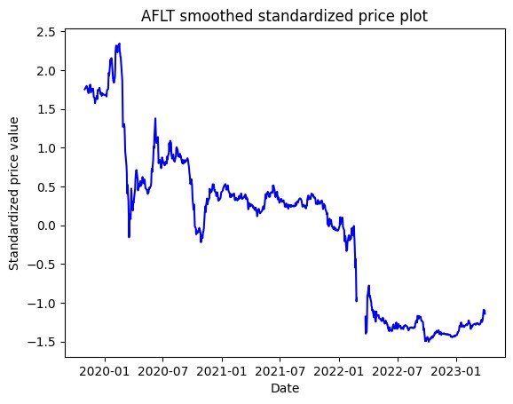 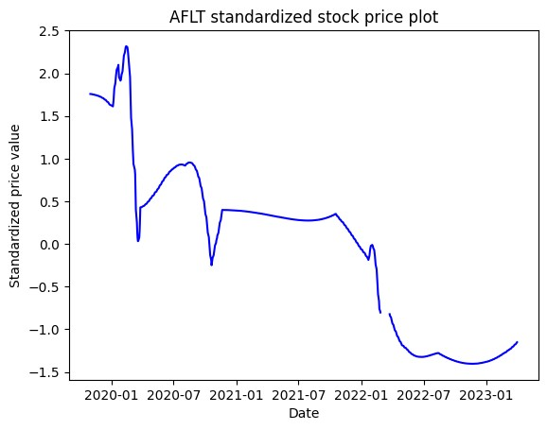

a) b)

Fig. 1. Smoothing a time series with one-dimensional adaptive regression spline, the example of the Aeroflot company: standardized stock price time series (a) and smoothed time series (b).

To combine the series into groups based on the similarity of behavior throughout the entire study period, the k-means cluster analysis method with the DTW distance metric between time series was used. Since the DTW metric is designed to calculate the distance for series with a shift, it is necessary to set a limit on the allowable time shift. Within the framework of this study, an acceptable shift was considered to be a range not exceeding one month, therefore, a limit was set on the permissible window of the Sake-Chiba transformation [H. Sakoe and S. Chiba, 1978], equal to 10. The number of clusters was determined by the elbow method and taking into account the result interpretation and was chosen to be 4.

The analysis revealed that the share prices of some companies differ significantly from others and cannot be attributed to any cluster. The procedure for identifying such series was carried out as follows. 20 models were generated using the k-means method with different initial cluster centers and time series were determined that were more than 8 times more than 1000 units distant from the final cluster centers.Such series were classified as outliers and removed from the studied set of time series. They are the share prices of the following companies: CHGZ (RN-Western Siberia), ELTZ (Electrozinc), GAZP (Gazprom), IRKT (Irkut), KZOS (KazanOrgSintez), LNZL (Lenzoloto), SFIN (SFI) and TUZA (Tuymazinsky concrete truck plant).

For the remaining 151 rows, cluster analysis was performed again. Figures 2 shows stock price charts for the resulting clusters. Curves that deviate from the row average by a standard deviation are shown in black.

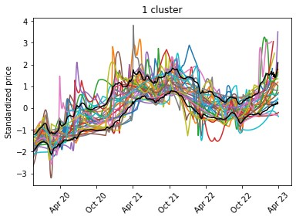 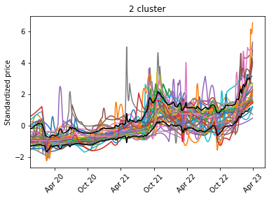

a) b)

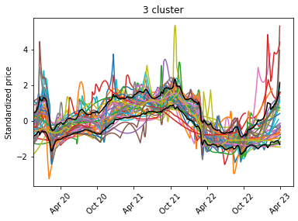 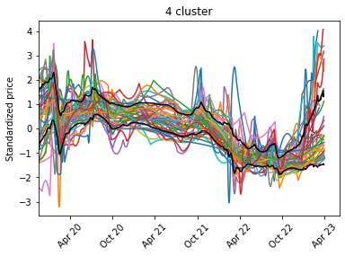

c) d)

Fig. 2. Stock price series grouped by clusters: (a) Cluster 1 – 30 companies; (b) Cluster 1 – 38 companies; (c) Cluster 1 – 39 companies; (d) Cluster 1 – 44 companies.

The behavior of the cluster prototype as its typical representative allows interpreting the behavior of the entire cluster. The prototype of the first cluster, found by the PAM method, turned out to be a smoothed series of Tattelecom stock prices (Fig. 3).

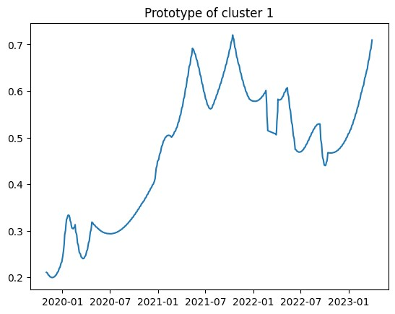

Fig.3. Cluster 1 prototype time series.

The behavior of the prototype describes the typical (average) behavior of stock prices of the cluster. The stock prices of the prototype of this cluster decreased by 17.7% during the pandemic in the period from 02.02.20 to 3.04.20 relative to the period 01.01.20-19.02.20. At the end of 2020, they recovered. Over the course of a year and a half, there was a significant increase in quotations - 83% for the period 04.04.20 - 29.10.21 relative to the period of the pandemic recession. The growth of quotations stopped during the sanctions in the winter-spring of 2022. In the period from 28.03.22 to 01.01.23 there was a drop in quotations by 19.7% compared to the period 01.08.21-21.09.22, however, at the end of the period under review, pre-sanction quotations were again reached. Thus, the impact of the pandemic and sanctions on the prototype of this cluster was negative, but not critical, and the recovery and further growth of quotations occurred quite quickly.

The prototype of the second cluster is a smoothed series of Belon stock prices (Fig. 4).

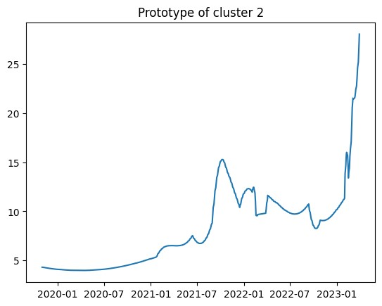

Fig.4. Cluster 2 prototype time series

Representatives of the second cluster practically did not feel the impact of the pandemic. Prototype stock prices fell by 1.4% from 02.02.20 to 03.04.20 to the period 01.01.20-19.02.20. In the period 04.04.20-29.10.21, share prices began to rise, increasing by 59.7% compared to the pandemic period. The growth stopped due to the introduction of another package of sanctions: there was a drop in quotes by 17.02% in the period 28.03.22-01.01.2023 to the period 01.08.2021- 29.01.2022. At the end of 2022, the prototype's share prices began to rise sharply again, increasing by 65.4% for the period 01.01.2023-31.03.2023 relative to the period 28.03.2022-01.01.2023. Thus, the pandemic did not affect the prototype and the representatives of this cluster as a whole, and the sanctions had only a slight negative impact.

The prototype of the third cluster is a smoothed series of GAZ company share prices (Fig. 5).

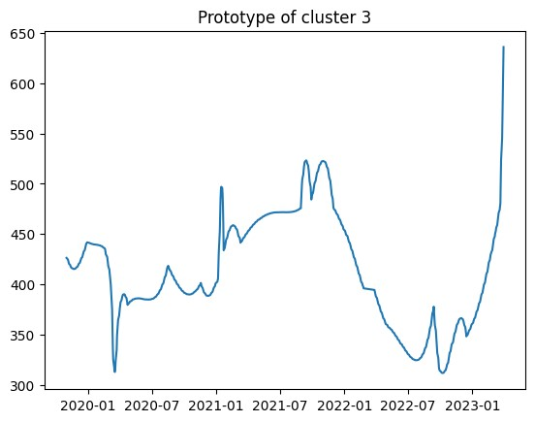

Fig.5. Cluster 3 prototype time series

The quotes of the third cluster representatives felt a drop during the pandemic. The prototype's quotes fell by 15.1% over the period 20.02.2020 - 03.04.2020 relative to the period 01.01.2020 - 19.02.2020. In 2021, the share prices of the third cluster companies exceeded the pre-pandemic level. The growth of the prototype quotes for the period 04.04.2020 - 29.10.2021 amounted to 16.8% compared to the period 20.02.2020 - 03.04.2020. During the sanctions, stock prices fell. The quotes of the prototype for the period 28.03.2022 - 31.10.2022 decreased by 31.02% compared to the period 01.08.2021 - 29.10.2021. Recovery from this shock did not appear until 2023. Thus, both the pandemic and the sanctions had a significant impact on the representatives of this cluster, but as a result, their quotes were restored.

The prototype of the fourth cluster is a smoothed series of stock prices of the Tomsk Distribution Company (Fig. 6).

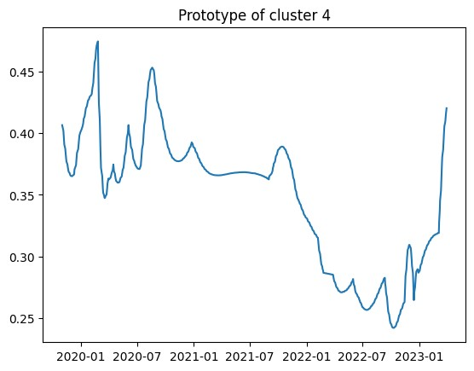

Fig.6. Cluster 4 prototype time series

Representatives of the fourth cluster experienced a drop in stock prices during the pandemic. The prototype quotes fell by 12.1% for the period 20.02.2020 - 03.04.2020 compared to the period 01.01.2020 - 19.02.2020. The fall in quotations continued in the post-pandemic period. During the period 1.12.2022 - 25.02.2022, the drop in prototype quotes was 14.13% compared to the period 01.08.2021 - 29.10.2021. During the sanctions period 28.03.2022 - 31.10.2022, the drop in prototype quotes was 29.59% compared to the period 01.08.2021 - 29.10.2021. The recovery of quotations occurred from the end of 2022. Prototype quotes for the period 01.11.2022 - 31.03.2023 amounted to 10.42% compared to the period 01.12.2021 - 31.10.2022.

The quotation change of 8 companies differs from the quotation change of the identified groups. Figure 8 shows a smoothed series of Gazprom stock quotes.

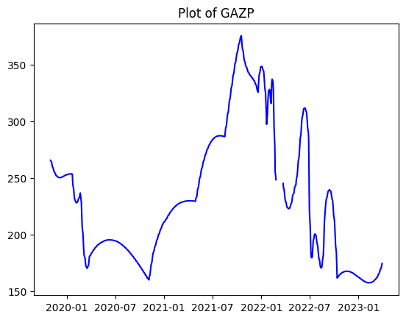

Fig.7. Smoothed Gazprom stock quotes time series

The company's stock prices showed significant growth in the post-pandemic period. Since the end of 2021, there has been a downward trend in the stock price of this company, despite short-term periods of growth.

Figure 8 shows a smoothed series of stock quotes for KazanOrgSintez. In general, the quotes of this company show significant fluctuations over different periods of time.

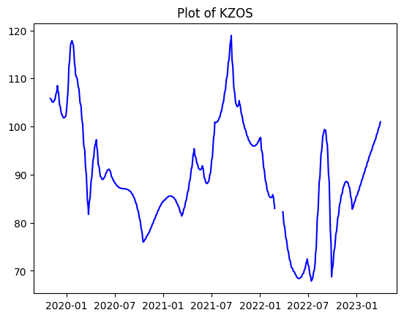

Fig.8. Smoothed KazanOrgSintezstock quotes time series

Table 1 shows the composition of clusters by industry: the distribution of the number of companies in each industry by cluster, highlighting the number of companies that did not fall into any cluster.

Table 1: Distribution of companies in different industries by clusters

|  |  |  |  |  |  |  |
| --- | --- | --- | --- | --- | --- | --- |
|  | **Cluster number** | | | | **Total by cluster** | **Outliers** |
| **Industry** | **1** | **2** | **3** | **4** |
| Aerospace |  | 2 | 1 |  | 3 | 1 |
| Automotive industry | 2 | 1 | 1 | 2 | 6 |  |
| Banking and financial sector | 4 | 3 | 7 | 1 | 15 | 1 |
| Biotechnology |  | 2 |  |  | 2 |  |
| Ferrous metallurgy | 1 | 4 | 4 |  | 9 |  |
| Oil and gas industry | 2 | 1 | 5 | 6 | 14 | 1 |
| Consumer sector | 4 | 3 | 5 | 2 | 12 |  |
| Industrial production (except automobiles) | 3 | 1 | 1 | 1 | 6 | 1 |
| Real estate sector | 1 |  | 1 | 2 | 4 | 1 |
| Telecommunications | 1 |  |  | 5 | 6 |  |
| Transport |  | 2 |  | 3 | 5 |  |
| Coal industry |  | 4 |  |  | 4 |  |
| Chemical industry |  | 4 | 2 |  | 6 | 1 |
| Non-ferrous metallurgy | 4 | 1 | 3 | 2 | 10 | 2 |
| Electric power industry | 8 | 10 | 9 | 20 | 47 |  |
| **Grand total** | **30** | **38** | **39** | **44** | **151** | **8** |

For some industries all or almost all representatives proved to be located in one and the same cluster or clusters with similar trends (with rising or falling share prices), for example, the coal, oil and gas or telecommunications industries. Such industries are characterized by strong dependence on commodity prices or some other specific macroeconomic events.

For other industries,representatives were distributed across all clusters, for example, the electric power industry, non-ferrous metallurgy or the financial and consumer sector. For companies in these industries, belonging to a particular cluster depended on individual factors, such as falling under sanctions, preparedness for international supply chains to be destroyed during the pandemic, competitors leaving the Russian market, government support and the importance of production for the global consumer. A possible factor that influenced the reaction of company quotes to macroeconomic shocks is the organization of internal business processes of companies. A significant role belongs to possible state funding or an increasing the state's share in companies in some industries.

The distribution of large companies with assets exceeding 1 trillion RUR among clusters and their share in the total number of cluster companies are presented in Table 2.

Table 2: Composition of clusters by company size

|  |  |  |  |  |
| --- | --- | --- | --- | --- |
| Cluster | **1** | **2** | **3** | **4** |
| Companies with assets >1 tn RUR | 3 | 3 | 9 | 8 |
| Number of companies in total | 30 | 38 | 39 | 44 |
| Share | 10,00% | 7,89% | 23,08% | 18,18% |

Most large companies ended up in clusters 3 and 4, which were more strongly influenced by negative macroeconomic factors in the study period than the first two clusters. This confirms the correctness of the government measures taken to support large businesses in Russia in the period from 2019 to 2023.

**Conclusion**

Clustering of time series of quotations for shares of 159 companies in the Russian Federation was carried out to identify segments of companies that had different reactions to negative macroeconomic factors in the period from November 2019 to April 2022. Four clusters of companies demonstrating similar behavior and eight companies not belonging to any cluster were identified. The influence of macroeconomic factors was considered directly during the period of their impact. Delayed effects were not taken into account.

As a result of the empirical analysis, the following conclusions were obtained regarding the hypotheses.

Hypothesis H1 was confirmed: Four clusters with significantly different reactions were identified. The stock prices of Cluster 1 companies declined during the pandemic and quickly recovered and then showed significant growth. Growth stopped during the period of sanctions, but by the beginning of 2023, stock prices had recovered to pre-sanction levels. Thus, the impact of the pandemic and sanctions was negative, but short-term. Cluster 2 companies hardly felt the impact of the pandemic, and the negative impact of sanctions was small. Both the pandemic and sanctions had a significant impact on companies in cluster 3. However, by the end of the period under review, quotes recovered. Share prices of companies in cluster 4 were unstable during the pandemic period with a further decline, which intensified during the sanctions period. By the end of the period under review, there was a partial recovery of quotes.

Hypothesis H2 was confirmed: Companies belonging to the same industry found themselves in different clusters. Companies that do not fall into any cluster also have different industry affiliations.

Analysis of clusters by size of companies confirmed the timeliness of the policy of state support for large businesses in Russia.

**Acknowledgements**

This study was supported by the Russian Science Foundation (project No. 20-18-00365, <https://rscf.ru/project/23-18-45035/>).

**References**

Aghabozorgi, S., Shirkhorshidi, A. S., & Wah, T. Y. (2015). Time-series clustering–a decade review. *Information systems*, *53*, 16-38. <https://doi.org/10.1016/j.is.2015.04.007>

Ankudinov, A., Ibragimov, R., & Lebedev, O. (2017). Sanctions and the Russian stock market. *Research in International Business and Finance*, *40*, 150-162. <https://doi.org/10.1016/j.ribaf.2017.01.005>

Arbelaitz, O., Gurrutxaga, I., Muguerza, J., Pérez, J. M., & Perona, I. (2013). An extensive comparative study of cluster validity indices. *Pattern recognition*, *46*(1), 243-256. <https://doi.org/10.1016/j.patcog.2012.07.021>

Balcilar, M., Bonato, M., Demirer, R., & Gupta, R. (2018). Geopolitical risks and stock market dynamics of the BRICS. *Economic Systems*, *42*(2), 295-306. <https://doi.org/10.1016/j.ecosys.2017.05.008>

Berndt, D. J., & Clifford, J. (1994, July). Using dynamic time warping to find patterns in time series. In *Proceedings of the 3rd international conference on knowledge discovery and data mining* (pp. 359-370).

Bradley, P. S., & Fayyad, U. M. (1998, July). Refining initial points for k-means clustering. In *ICML*, *98*, 91-99.

Buszko, M., Orzeszko, W., & Stawarz, M. (2021). COVID-19 pandemic and stability of stock market—A sectoral approach. *Plos one*, *16*(5), e0250938. <https://doi.org/10.1371/journal.pone.0250938>

De Luca, G., & Zuccolotto, P. (2017). A double clustering algorithm for financial time series based on extreme events. *Statistics & Risk Modeling*, *34*(1-2), 1-12. <https://doi.org/10.1515/strm-2015-0026>

Ding, D., Guan, C., Chan, C. M., & Liu, W. (2020). Building stock market resilience through digital transformation: using Google trends to analyze the impact of COVID-19 pandemic. *Frontiers of Business Research in China*, *14*(1), 1-21. https://doi.org/10.1186/s11782-020-00089-z

Drobot E.V. (2020). Mirovaya ekonomika v usloviyakh pandemii COVID-19: itogi 2020 goda i perspektivy vosstanovleniya [Global economy in the context of the COVID-19 pandemic: results of 2020 and prospects for recovery]. *Ekonomicheskie otnosheniya*, *10*(4), 937-960. (In Russ.) doi: 10.18334/eo.10.4.111375

Durrleman, S., & Simon, R. (1989). Flexible regression models with cubic splines. *Statistics in medicine*, *8*(5), 551-561. <https://doi.org/10.1002/sim.4780080504>

El Montasser, G., Charfeddine, L., & Benhamed, A. (2022). COVID-19, cryptocurrencies bubbles and digital market efficiency: sensitivity and similarity analysis. *Finance Research Letters*, *46*, 102362. <https://doi.org/10.1016/j.frl.2021.102362>

Friedman, J. H. (1991). Multivariate adaptive regression splines. *The annals of statistics*, *19*(1), 1-67. DOI: 10.1214/aos/1176347963

Friedman, J. H. (1991). *Estimating functions of mixed ordinal and categorical variables using adaptive splines* (pp. 1-42). Department of Statistics, Stanford Univ.

Ghasseminejad, S., & Jahan-Parvar, M. R. (2021). The impact of financial sanctions: The case of Iran. *Journal of Policy Modeling*, *43*(3), 601-621. https://doi.org/10.1016/j.jpolmod.2021.03.001

Gurvich, E., & Prilepskiy, I. (2015). The impact of financial sanctions on the Russian economy. *Russian journal of economics*, *1*(4), 359-385. <https://doi.org/10.1016/j.ruje.2016.02.002>.

Hsu, Y. C., & Chen, A. P. (2014). A clustering time series model for the optimal hedge ratio decision making. *Neurocomputing*, *138*, 358-370. <https://doi.org/10.1016/j.neucom.2014.01.026>

Hufbauer, G., Schott, J., & Elliott, K. (2009). *Economic Sanctions Reconsidered*. Peterson Institute for International Economics.

Iorio, C., Frasso, G., D’Ambrosio, A., & Siciliano, R. (2018). A P-spline based clustering approach for portfolio selection. *Expert Systems with Applications*, *95*, 88-103. <https://doi.org/10.1016/j.eswa.2017.11.031>

Kaufman, L., Rousseeuw, P. (1990). Partitioning around medoids (program pam). Finding groups in data: an introduction to cluster analysis. *Wiley*, *Hoboken*. [https://doi.org/10.1002/9780470316801](https://doi.org/10.1002/9780470316801.ch2)

Khan, K., Zhao, H., Zhang, H., Yang, H., Shah, M. H., & Jahanger, A. (2020). The impact of COVID-19 pandemic on stock markets: An empirical analysis of world major stock indices. *The Journal of Asian Finance, Economics and Business*, *7*(7), 463-474. DOI:[10.13106/jafeb.2020.vol7.no7.463](https://doi.org/10.13106/jafeb.2020.vol7.no7.463)

Cholodilin, K. A., Netšunajev, A. (2016). *Crimea and punishment: The impact of sanctions on Russian and European economies*, DIW Discussion Papers, No. 1569, Deutsches Institut für Wirtschaftsforschung (DIW), Berlin

Kupriyanova, L. M., & Sokolinskaya, N.E. (2018). Fundamental analysis of securities issuer. *Mir novoj ekonomiki = World of the new economy*, *12*(1), 114–123. (In Russ.) DOI: 10.26794/2220-6469-2018-12-1-114-123

Liao, T. W. (2005). Clustering of time series data—a survey. *Pattern recognition*, *38*(11), 1857-1874. <https://doi.org/10.1016/j.patcog.2005.01.025>

Lin, J., Keogh, E., Lonardi, S., & Chiu, B. (2003, June). A symbolic representation of time series, with implications for streaming algorithms. In *Proceedings of the 8th ACM SIGMOD workshop on Research issues in data mining and knowledge discovery* (pp. 2-11). <https://doi.org/10.1145/882082.882086>

Malkina M.Yu., & Ovcharov A.O. (2022). Financial Contagion of Russian Companies from the Oil Market under the Influence of Sanctions and Pandemic Shock. *Financial Journal*, *14*(4), 8–28 (In Russ.). https://doi.org/10.31107/2075-1990-2022-4-8-28

Malkina, M.Yu., Yakovleva, E.K. (2016). Analysis of the influence of macroeconomic and industrial factors on companies' stock price. *Finance and Credit*, 44(716) 33–47. (In Russ.)

Mazur, M., Dang, M., & Vega, M. (2021). COVID-19 and the march 2020 stock market crash. Evidence from S&P1500. *Finance research letters*, *38*, 101690. <https://doi.org/10.1016/j.frl.2020.101690>

Naidu, D., & Ranjeeni, K. (2021). Effect of coronavirus fear on the performance of Australian stock returns: Evidence from an event study. *Pacific-Basin Finance Journal*, *66*, 101520. <https://doi.org/10.1016/j.pacfin.2021.101520>

Salvador, S., & Chan, P. (2007). Toward accurate dynamic time warping in linear time and space. *Intelligent Data Analysis*, *11*(5), 561-580.

Sakoe, H., & Chiba, S. (1978). Dynamic programming algorithm optimization for spoken word recognition. *IEEE transactions on acoustics, speech, and signal processing*, *26*(1), 43-49. DOI: [10.1109/TASSP.1978.1163055](https://doi.org/10.1109/TASSP.1978.1163055)

Shehzad, K., Xiaoxing, L., & Kazouz, H. (2020). COVID-19’s disasters are perilous than Global Financial Crisis: A rumor or fact? *Finance research letters*, *36*, 101669. <https://doi.org/10.1016/j.frl.2020.101669>

Sinyakov, A., Roitman, A., & Seleznyov, S. (2015). *Dynamics of Russia's potential GDP after the oil shock: The role of large change in relative prices and structural rigidities* (Bank of Russia Working Paper Series, No. 6). Moscow: Bank of Russia (In Russian).

Sukharev, O. S., & Voronchikhina, E. N. (2022). Development of countries under sanctions: Iran and Russia. *R-Economy. 2022. Vol. 8. Iss. 3*, *8*(3), 219-236.

Topcu, M., & Gulal, O. S. (2020). The impact of COVID-19 on emerging stock markets. *Finance research letters*, *36*, 101691. <https://doi.org/10.1016/j.frl.2020.101691>

Velichko, V. M., & Zagoruyko, N. G. (1970). Automatic recognition of 200 words. *International Journal of Man-Machine Studies*, *2*(3), 223-234. <https://doi.org/10.1016/S0020-7373(70)80008-6>

Zimovets A.V., Sorokina Yu.V., & Khanina A.V. (2020). Analiz vliyaniya pandemii COVID-19 na razvitie predpriyatiy v Rossiyskoy Federatsii [Analysis of the impact of the COVID-19 pandemic on the development of enterprises in the Russian Federation]. *Ekonomika, predprinimatelstvo i pravo. 10*(5), 1337-1350. (In Russ.) doi: 10.18334/epp.10.5.110126